CREATIVE EDUCATIONAL SERVICES KAMPALA
P. 7 EXAMINATION SET 3 2026

Integrated Science

Time allowed: 2 hours 15 minutes

NAME: ____________________________________________

Signature: __________________________________________
EXAMINER’S USE ONLY
Stream ________________________
A
B
TOTAL

Date ________________________

Read the following instructions carefully:
- The paper is made up of section A and B.
- Section A has 40 short answer questions (40 marks).
3. Section B has 15 questions (60 answers).
4. Answer ALL questions. All answers to both section A and B must be written in the spaces provided.
5. All answers must be written in blue ink.
6. Any handwriting that cannot easily be read will lead to loss of marks.
7. Unnecessary alteration of work may lead to loss of marks.
8. Do not write anything in the box indicated examiner’s use only.

PARENT’S COMMENT | SIGNATURE

SECTION A: 40 MARKS
- Name any one example of a reptile.
_______________________________________________________________
- Identify the function of the heart in the body.
_______________________________________________________________
- Why are gaps left between the rails during railway line construction?
_______________________________________________________________
- Give any one example of a plant which stores its food in a stem.
_____________________________________________________________
- The diagram below shows a garden tool used for transplanting. Name the garden tool shown below.
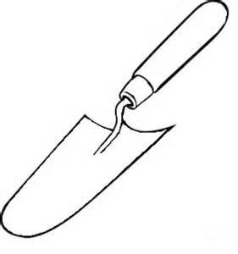
_______________________________________________________________
- How can the health of teeth be maintained?
_______________________________________________________________
- Write down one example of a disease that affects the muscular skeletal system.
_______________________________________________________________
- Name the smallest unit of matter that cannot be split any further.
_______________________________________________________________
- How do people in Uganda benefit from wind?
_______________________________________________________________
- Of what importance is chlorophyll to plant?
_______________________________________________________________
- Give any one example of a social insect.
_______________________________________________________________
- Identify any one product from milk.
_______________________________________________________________
- Where does alcohol get absorbed during the process of food digestion?
_______________________________________________________________
- State any one secondary sex characteristic that occurs in both males and females.
_______________________________________________________________
- Why does a maize plant fold its leaves during dry season?
______________________________________________________________
- Why is the proper disposal of wastes very important in our community?
______________________________________________________________

- In which way is rusting similar to burning?
_______________________________________________________________
- How does sound move from one place to another?
_______________________________________________________________
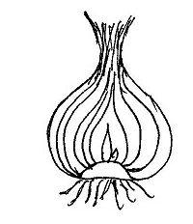
Study the diagram of a plant below and answer the questions that follow.

- State the type of root system the above plant has.
_______________________________________________________________
- How can scurvy be prevented in human beings?
_______________________________________________________________
- Why is a larva of a butterfly not liked by farmers?
_______________________________________________________________
- Name the fungi used in fermentation process?
_______________________________________________________________
- In the space provided below, calculate the mass of an object whose density is 10g/cc and volume is 5cc.

- Name the form of energy that enables to iron clothes.
_______________________________________________________________
- What is the use of arm sling in giving first aid?
_______________________________________________________________
- At what time of the day do shadows appear longest?
_______________________________________________________________
- How is a frog similar to a fish in the way they reproduce?
_______________________________________________________________
- Why is it important to wash hands before touching food?
_______________________________________________________________
- Write any material used as an insulator during cooking of food.
_______________________________________________________________
- Which component of blood that transports digested food in the body?
_______________________________________________________________
- Identify any one immunisable water borne disease.
_______________________________________________________________
- Which part of the skeleton protects the brain?
_____________________________________________________________
- What is the importance of water during seed germination?
_______________________________________________________________
- Mention the property of air shown in the diagram below.
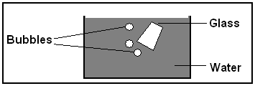

_______________________________________________________________
- How can soil erosion be prevented in hilly areas?
_____________________________________________________________
- By what process does paraffin move through the wick of the lamp?
_______________________________________________________________
- What name is given to the breathing organs of an insect?
_______________________________________________________________
- Identify the basic need of man that prevents hunger?
_______________________________________________________________
- What advise can you give a farmer whose hens are laying eggs with soft shells?
_______________________________________________________________
- How do tape words find their way into our bodies?
_______________________________________________________________
SECTION B: 60 MARKS
- a) State two ways of maintaining soil fertility.
- ____________________________________________________________
- ____________________________________________________________
b) Outline two types of soil.
i) ____________________________________________________________
ii) _____________________________________________________________
- a) State any two systems of keeping poultry.
- ____________________________________________________________
- ____________________________________________________________
b) State the role of the following found in the poultry house.
i) Litter:
______________________________________________________________
ii) Feeding trough
_______________________________________________________________
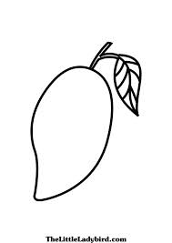
- Study the diagram of a fruit below and answer the following questions.

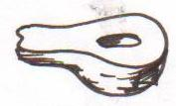

- Under what type of succulent fruits is the fruit drawn?
____________________________________________________________
- In which way is the above fruit different from a berry?
____________________________________________________________
- Give two examples of fruits with many seeds inside?
- _______________________________________________________
- ______________________________________________________
- a) What name is given to an immovable joint found on the skull?
_______________________________________________________________
b) Identify the food nutrient that is required to strengthen the bones and teeth.
______________________________________________________________
c) State any two functions of the skeleton.
i) ____________________________________________________________
ii) _____________________________________________________________
- a) Identify one example of goats kept for milk production.
_______________________________________________________________
b) What is the gestation period of a goat?
_______________________________________________________________
c) Mention any one sign of a goat on heat.
_______________________________________________________________
d) Name the product of goats used in making leather.
_______________________________________________________________
- a) Name the harmful chemical found in tobacco smoke.
_____________________________________________________________
b) What happens to the unborn baby of a pregnant mother who smokes?
_______________________________________________________________
c) Name any two respiratory diseases.
i) _____________________________________________________________
ii) _____________________________________________________________

- a) Write PHC in full.
_______________________________________________________________
b) State any two elements of P.H.C
i) _____________________________________________________________
ii) _____________________________________________________________
c) Give one example of vulnerable group of people.
_______________________________________________________________
- Mulching of soil is a very important practice in crop growing.
- Give two examples of mulches commonly used in Uganda.
- _______________________________________________________
- _______________________________________________________
- State two advantages of mulching a garden.
- _____________________________________________________
- _______________________________________________________
- a) How do most fungi reproduce?
_______________________________________________________________
b) Give two examples of fungi.
i) _____________________________________________________________
ii) _____________________________________________________________
c) In which one way is fungi useful to man?
_______________________________________________________________
- The diagram below is of a bean seed structure. Study it and answer the questions.
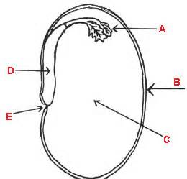
I
J
M
- Name the parts marked by M.
____________________________________________________________
- What will parts J and I develop into after germination?
J __________________________________________________________
I ___________________________________________________________
- What type of germination will the seed undergo?
____________________________________________________________
- a) What is temperature?
_______________________________________________________________
b) Name the instrument used to measure temperature.
_____________________________________________________________
c) Convert 50⁰C to ⁰F. (2marks)

- a) How does poor personal hygiene affect a human being?
__________________________________________________________
b) Mention two activities which promote hygiene at school.
i) _________________________________________________________
ii) _________________________________________________________
c) Draw and name any one item used to promote sanitation.

____________________________________________________________
- a) What is the work of a wind vane?
_______________________________________________________________
b) In which way can a house be guarded against strong wind?
_______________________________________________________________
c) Outline any two types of clouds.
i) _________________________________________________________
ii) __________________________________________________________
- The diagram below illustrates two types of sound waves (M and N). Use it to answer the questions that follow.
M
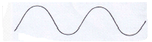
N

- Which type of wave represents the high pitch of sound?
___________________________________________________________
- What is noise?
____________________________________________________________
- Write any two devices that store sound.
- _______________________________________________________
- _______________________________________________________
- a) Name any two types of cattle.
i) ____________________________________________________________
ii) _____________________________________________________________
b) How can farmers improve on the quality of local breeds of cattle?
_______________________________________________________________
c) Mention any one tick borne disease that affects cattle.
_______________________________________________________________

END

